Week 5

You should be able to complete the following programs by the end of the week. By now you

should understand why you should be saving your work to GitHub or similar. Possible

solutions will be uploaded to the main module GitHub repository every week. If you follow

that repo you should be able to receive notifications.

Aer this week you should be able to run your programs from the command-line, without

having to use an IDE.

Note: Most of these programs process command-line arguments. In every case your program

should not crash if no arguments are provided. In most cases it should just exit with some

suitable error message.

1. Using command-line arguments involves the sys module. Review the docs for this

module and using the information in there write a short program that when run

from the command-line reports what operating system platform is being used.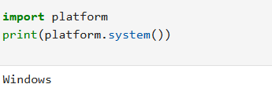

2. Write a program that, when run from the command line, reports how many

arguments were provided. (Remember that the program name itself is not an

argument).

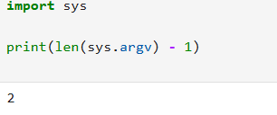

3. Write a program that takes a bunch of command-line arguments, and then prints

out the shortest. If there is more than one of the shortest length, any will do.

Hint: Don't overthink this. A good way to find the shortest is just to sort them.

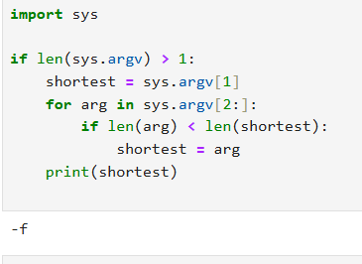

4. Write a program that takes a URL as a command-line argument and reports

whether or not there is a working website at that address.

Hint: You need to get the HTTP response code.

Another Hint: StackOverflow is your friend.

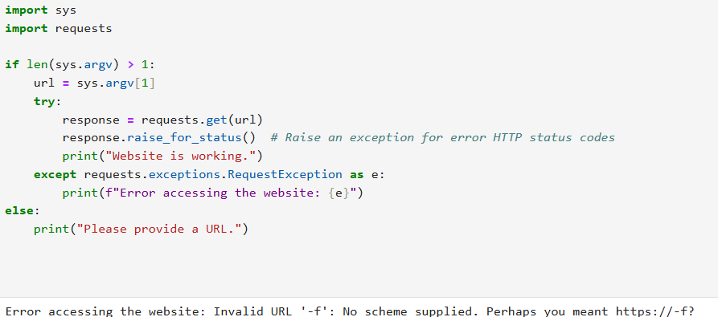

5. Last week you wrote a program that processed a collection of temperature readings

entered by the user and displayed the maximum, minimum, and mean. Create a

version of that program that takes the values from the command-line instead. Be

sure to handle the case where no arguments are provided!

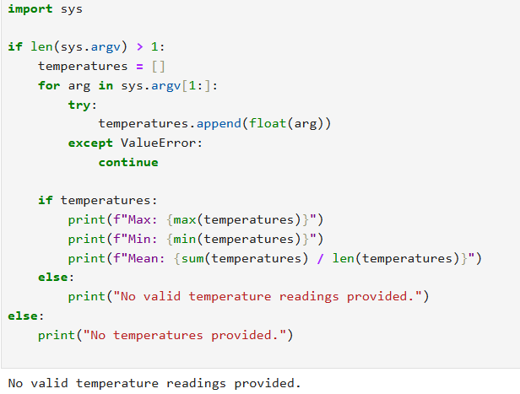

6. Write a program that takes the name of a file as a command-line argument, and

creates a backup copy of that file. The backup should contain an exact copy of the

contents of the original and should, obviously, have a different name.

Hint: By now, you should be getting the idea that there is a built-in way to do the

heavy liing here! Take a look at the "Brief Tour of the Standard Library" in the docs.

